FLIGHT NIGHTS at West Michigan Regional Airport

Flight Path welcomes students, pilots, and all aviation enthusiasts to learn about aviation and flying a Cessna 172 airplane with our Redbird and X-Plane VR flight simulators. The program is called FLIGHT NIGHT. It is free and open to all middle and high school students. Flight Path is an all-volunteer, not for profit 501(c)(3) charitable organization so you can help us by becoming a member of Flight Path, volunteering for events, or offering a financial donation.

The Flight Night sessions are scheduled one month at a time on Tuesday and Sunday nights. Check the Flight Path website page www.miflightpath.org for program details and the signup link for available dates and times. If you have questions about the Flight Night program or Flight Path, please email us at: info@miflightpath.org
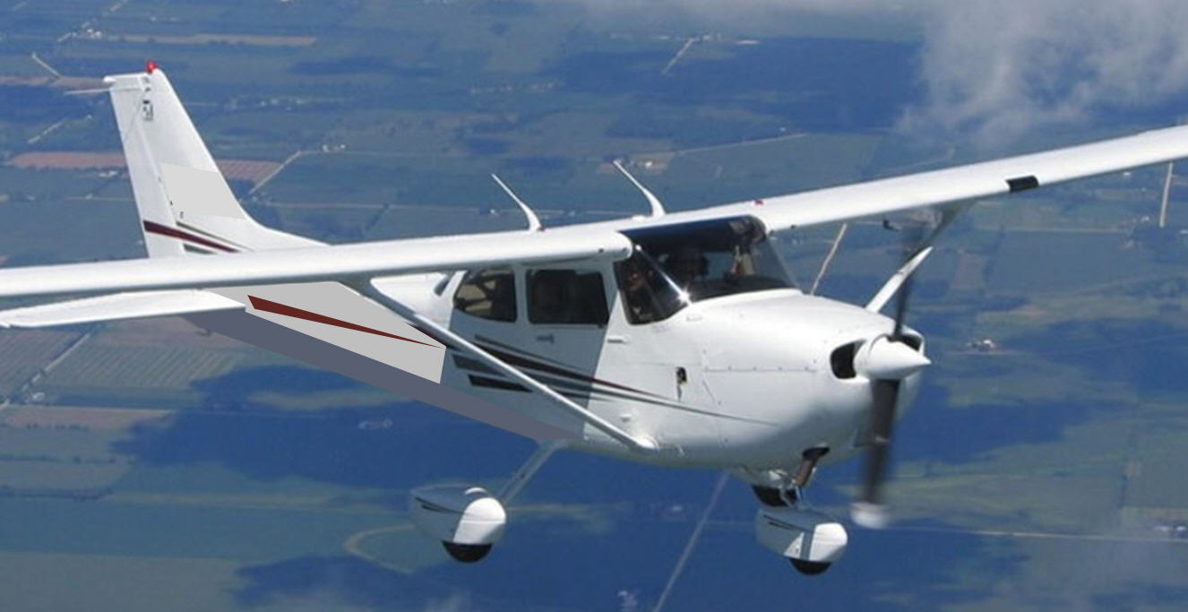
Flight Night Program
Student group size is 5 - 8 people (a guardian must attend with student)
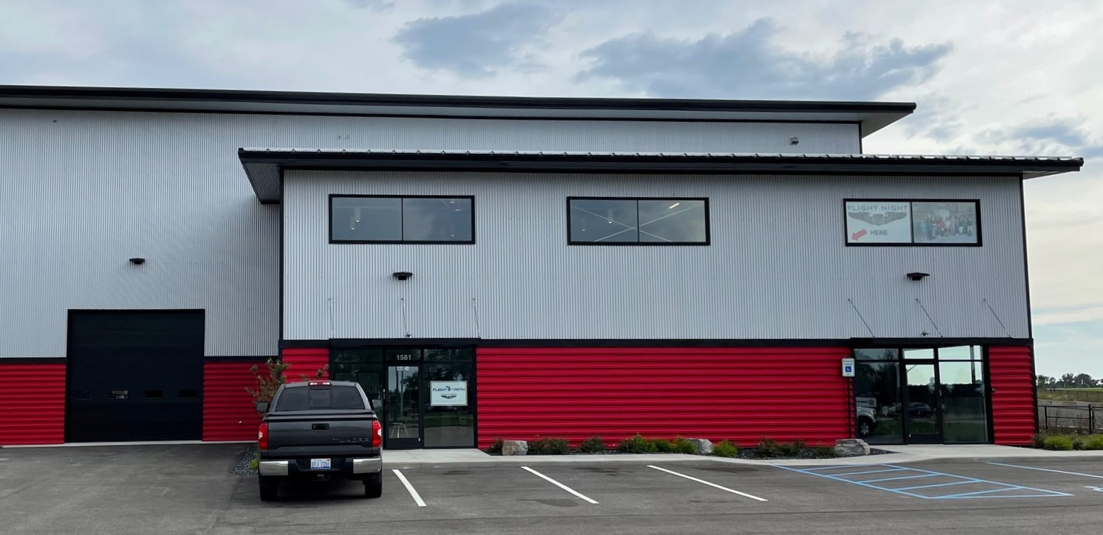
Program starts promptly at 6 pm for about 2 ½ hours.
Meet at the Fogg hangar at West Mi Regional Airport
1581 Geurink Blvd, Holland, MI 49424

Program content
- Sign-in, welcome and introductions. Brief presentation about history of aviation, aerodynamics, how do planes fly?
- Tour of aircraft in the hangars, sit at the controls, aircraft systems, flight controls, preflight checks, instruments.
- Talk to instructors, pilots, A&P mechanics, flight line specialists, learn about aviation jobs (varies with dates)
- Students learn to fly the Redbird TD 172 Cessna flight simulator, and the X-Plane 11 Virtual Reality flight simulators.
- Instructions for simulator operation, explanation of instruments and controls, maneuvers, beginning navigation.
- Students fly from an airport, climb, cruise and navigate, finally descending to enter final approach and then landing at the West Michigan Regional Airport. Flight time will depend upon the number of attendees.
- Time permitting we also have flight challenges: night flying, mountain flying challenge, emergency procedures….

Our 3 screen Redbird TD flight simulator is a certified system used by many commercial flight schools. Our two X-plane virtual reality systems offer a state of the art immersive experience! Flight Path is also working on a fourth full motion simulator which will be built into an actual Cessna 172 fuselage.

Please share your Flight Night experience with your friends and others. Post on our FLIGHT PATH Facebook page…
For more information about the Flight Night program go to http://miflightpath.org/flight-night-program/
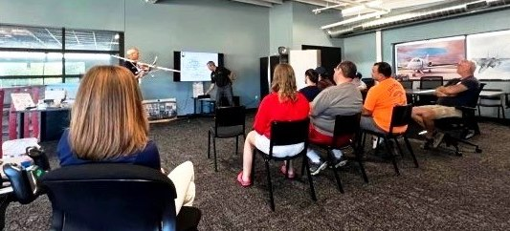
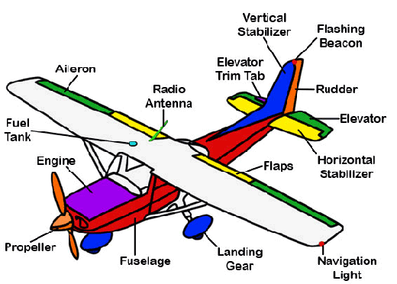
FLIGHT NIGHT
Sign up here
